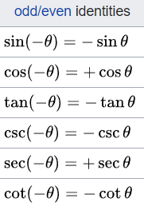**Trigonometric Relations:**C:\Users\Shane\School Classes\CPEG 323\HW\1e1007334e33157538f3d9c6b400ff58.png

C:\Users\Shane\School Classes\CPEG 323\HW\7f6f6791a6994bf29d2b3e4d788f823b.png

C:\Users\Shane\School Classes\CPEG 323\HW\9f825d4fae8307bf02314716c2dfab17.png

C:\Users\Shane\School Classes\CPEG 323\HW\51eb7092c768fe25ea5c81993149019e.png

C:\Users\Shane\School Classes\CPEG 323\HW\846949834d39ff220ba6ef57edbdb05b.png

**Linear Transformations:**

* **Laplace Transform**
  + *f(s) =* ∫f(t)e-st dt (Integration from 0 -> inf)
* **Inverse Laplace Transform**
  + *f(t) =1/2π* ∫f(t)est ds
* **Fourier Transform**
  + *f(jὠ) = =* ∫f(t)e-jὠt dt (Integration from -inf -> inf), *ὠ(0) = 2πf*
* **Inverse Fourier Transform**
  + *f(t) = =1/2π* ∫f(*ὠ*)ejὠt d*ὠ*

**Methods of Solving Differential Equations:**

* **Separation of Variables**
  + Used when you can separate all the independent variables and their derivatives onto both sides of the equation
  + Ex. *dy = ky dx* -> *dy/y = k dx*
    - Integrate both sides -> *ln(y) +C = kx +D* (Combine constants)
    - Put both sides in base *e* -> *y = ekx+C*
    - Simplify -> *y=Cekx* (Combine constants)
* **Integrating Factor**
  + Used for equation in the form *y’(x)+P(x)=Q(x)*
  + Integrating Factor = e∫P(x)dx
  + General Solution: ye∫P(x)dx = C+ ∫ e∫P(x)dx f(x)dx
* **Power Series Method**
* **Laplace Transform**
  + Take Laplace Transform
    - Integration by parts (usually)
    - *L(f’(t)) = sL[f(t)]-f(0)*
  + Simplify in *s*
  + Take inverse Laplace Transform
* **Diagonalization**
  + *Y’=AY*
  + *Det(A-λI) = 0*

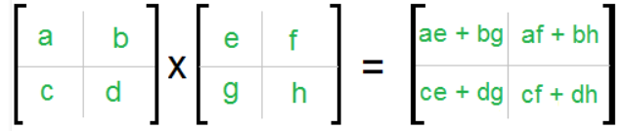**Linear Algebra**

* **Multiplying Matrices**
  + Row * column
* **Determinant of a Matrix**
  + Only an n*n (square) matrix has a determinant
  + N = 2 matrix:

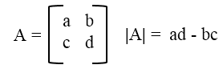

* + - D
  + N = 3 matrix:
    - 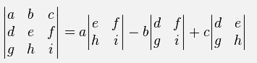a11M11 - a12M12+ a13M13
    - Mxy is the minor determinate
  + N = x
    - Continue the pattern for a N = 3 matrix
* **Inverse of a Matrix**
  + 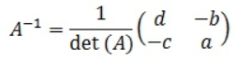2x2 matrix:
  + 3x3 matrix:
    - 1/det(A) *Adj(A)
      * Adj(A) is a matrix formed with the determinates of the minor matrices